🏕️ Abu Dhabi Camping Sites for Truck & 4WD Campers (With Iveco & Popup Camper Photos)
Abu Dhabi is one of the best regions in the UAE for off-road camping, especially for Iveco motorhomes, truck campers, and popup 4x4 campers. With vast deserts, remote beaches, and organized camping areas, it offers something for every type of camper.

🚐 Iveco Motorhome Camping Setup
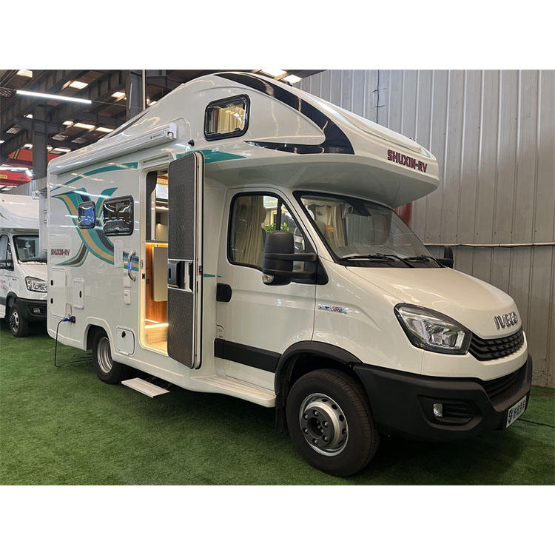
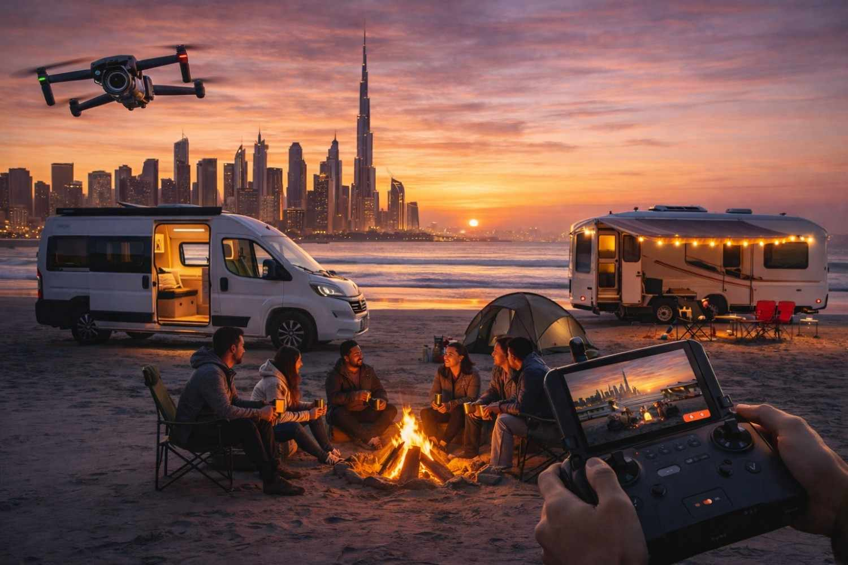

4
Iveco campers are ideal for:
- Long-distance travel
- Comfortable off-grid camping
- Family setups with full facilities
Perfect for places like Liwa Desert and Hudayriyat Island.

🛻 Truck Popup Camper Setup
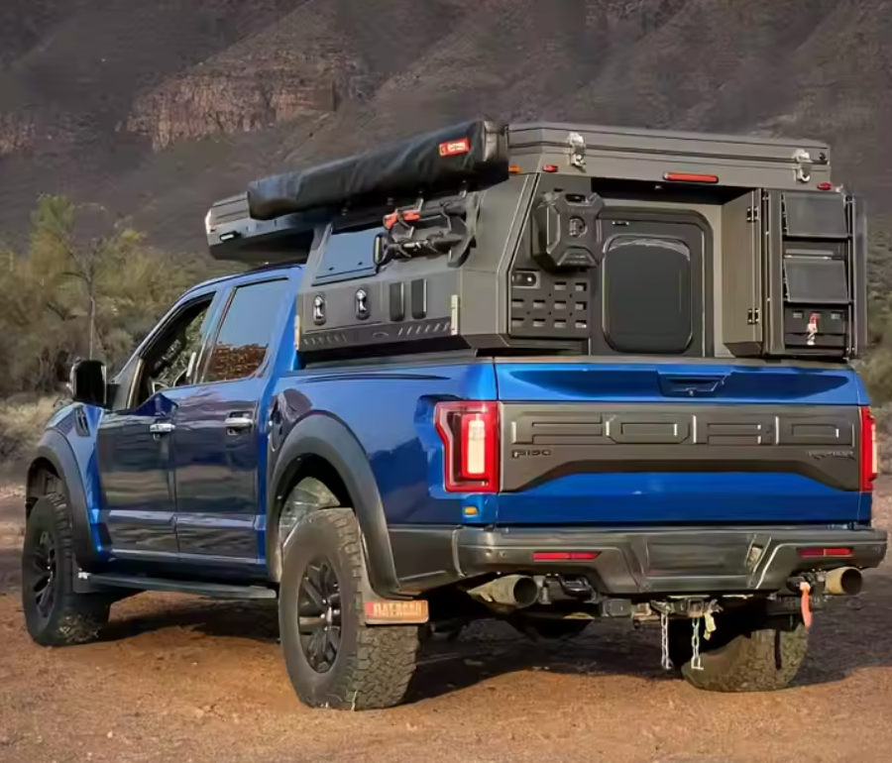
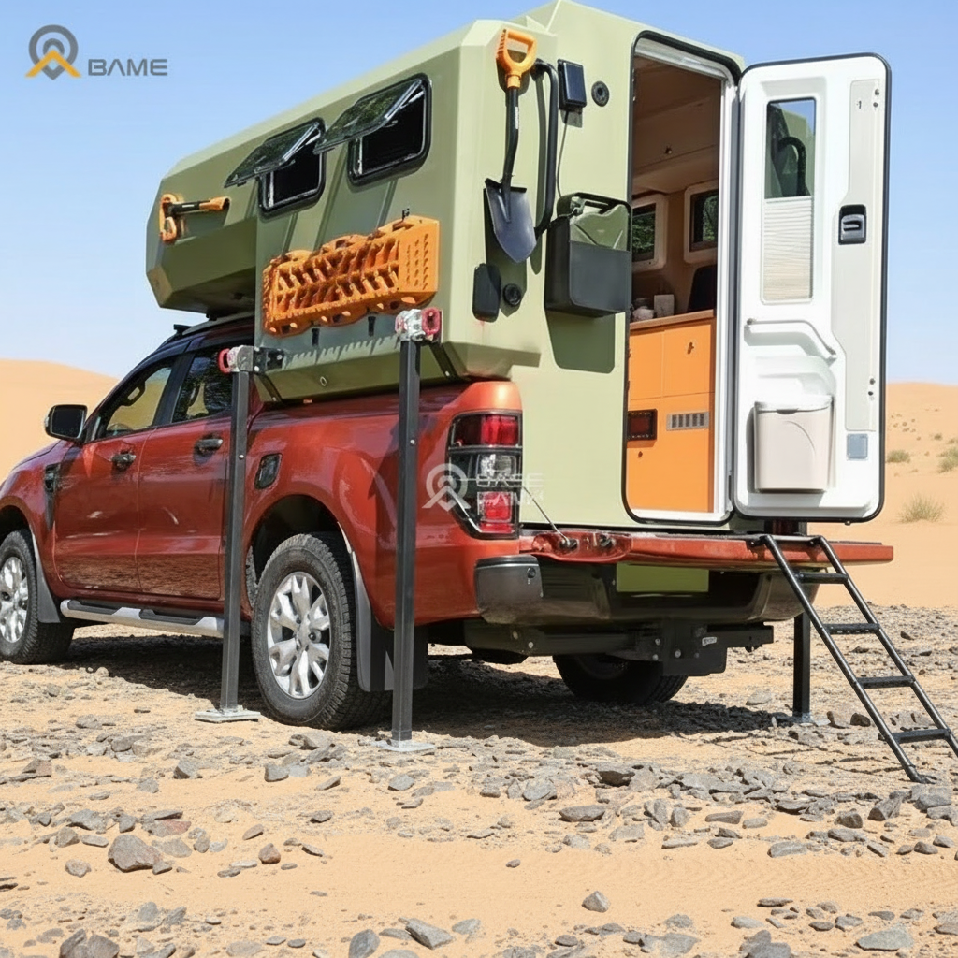
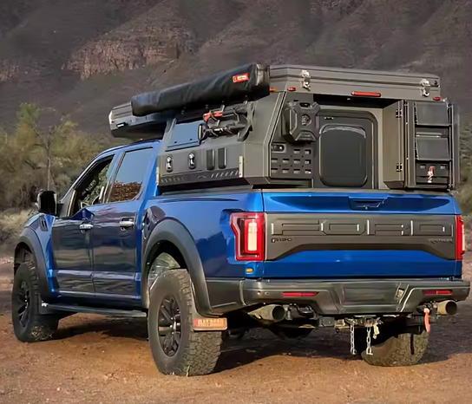
4
Truck popup campers are perfect for:
- Lightweight off-road exploration
- Quick setup and mobility
- Access to tighter dune areas
Best suited for Al Khatim Desert and remote areas in Al Dhafra.

🏜️ 1. Liwa Desert – Best for Iveco & Truck Campers
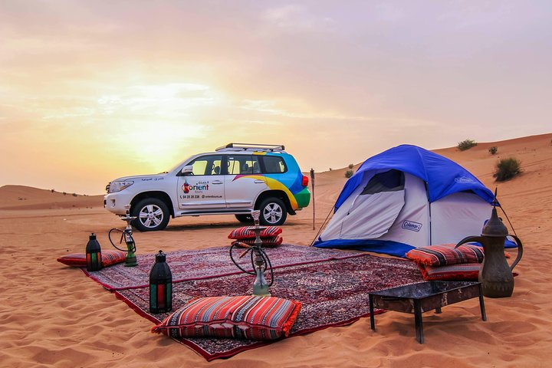
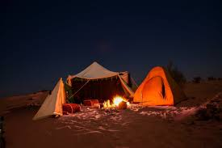
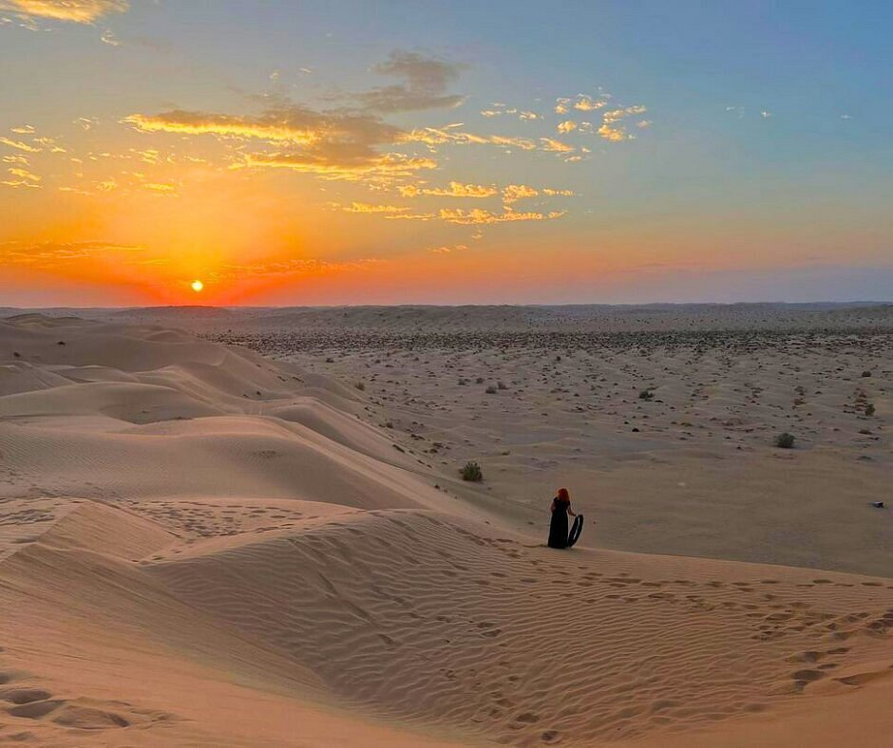
4
The Liwa Desert is the ultimate destination.
Ideal for:
- Iveco 4x4 motorhomes
- Truck popup campers
- Multi-day off-grid camping

🌊 2. Hudayriyat Island – Easy Beach Camping
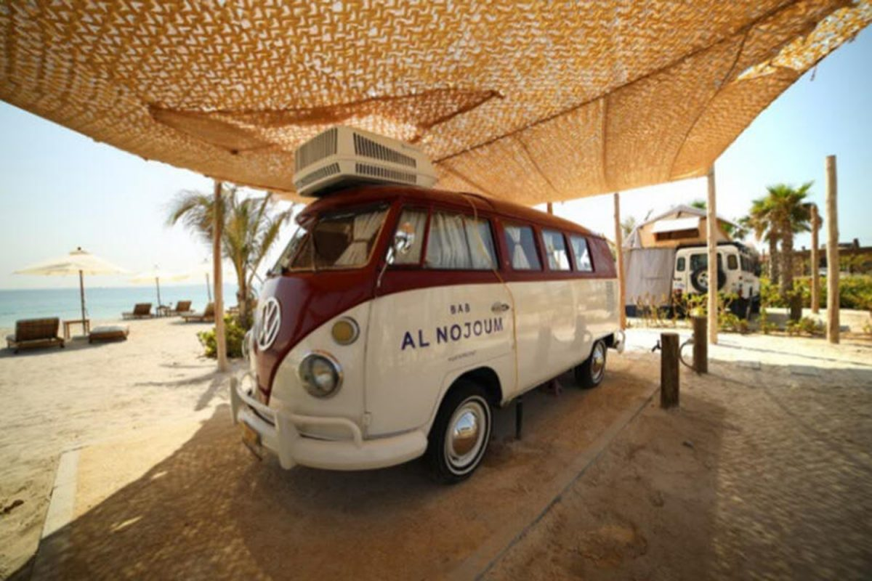
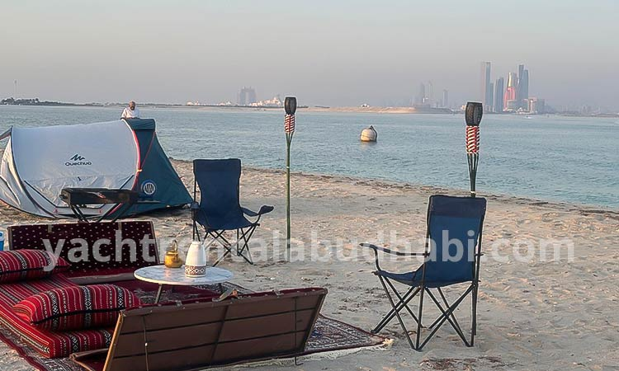
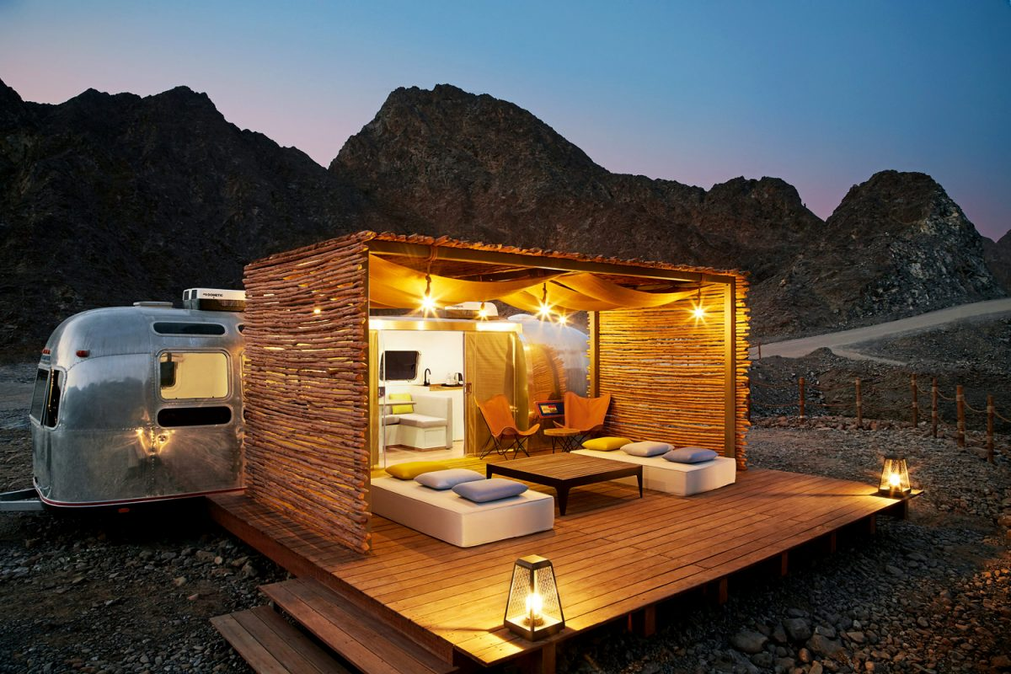
4
Hudayriyat Island offers:
- Easy access for all campers
- Facilities and family-friendly areas
- Perfect for showcasing premium camper setups

🏝️ 3. Al Dhafra – Remote Coastal Camping

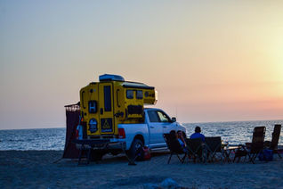
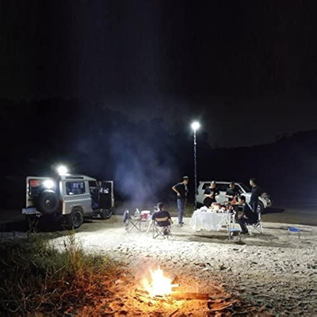
4
In Al Dhafra, you get:
- Complete privacy
- Stunning sunset + sea views
- Ideal for self-sufficient campers

🏜️ 4. Al Khatim Desert – Quick Off-Road Escape

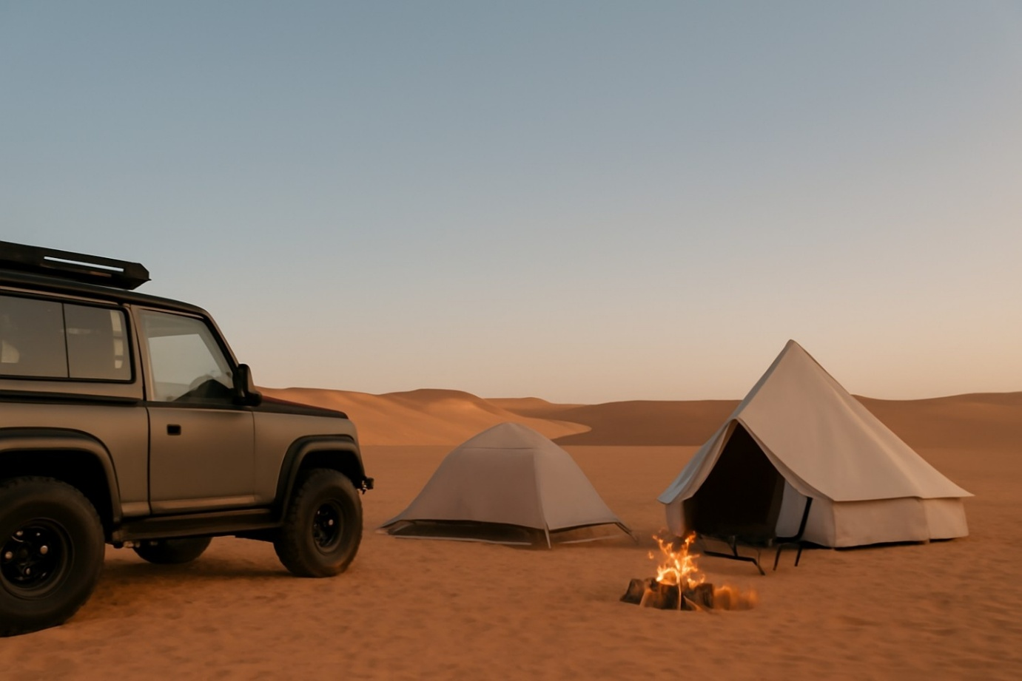
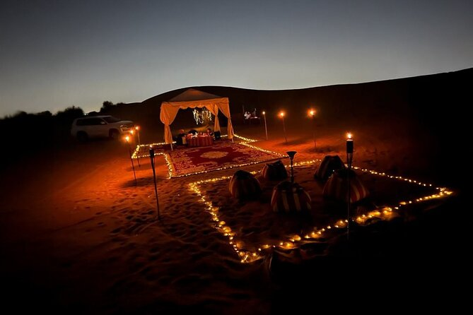
Al Khatim Desert is great for:
- Weekend trips
- Quick desert drives
- Testing camper setups

🚐 Pro Camping Setup Ideas (For Your Business)
- Outdoor chairs + table + lantern setup 🪑
- String lights for premium look 💡
- Portable BBQ & cooking station 🍖
- Branded setup (like Remal Caravan)

🌟 Final Thoughts
Whether you’re using an Iveco motorhome or a popup truck camper, Abu Dhabi offers top-tier camping experiences. From the dunes of Liwa to the beaches of Hudayriyat, every location is perfect for both adventure and lifestyle camping.

If you want next:
- I can add your actual Iveco or trailer photos into these locations (realistic edits)
- Create Instagram ads or brochures for Remal Caravan
- Design a full camping catalog with your vehicles

Voice

Ajman Motorhome Camping
You’re viewing user-generated content that may be unverified or unsafe.
Report
🏕️ Abu Dhabi Camping Sites for Truck & 4WD Campers (With Iveco & Popup Camper Photos)
Abu Dhabi is one of the best regions in the UAE for off-road camping, especially for Iveco motorhomes, truck campers, and popup 4x4 campers. With vast deserts, remote beaches, and organized camping areas, it offers something for every type of camper.

🚐 Iveco Motorhome Camping Setup



4
Iveco campers are ideal for:
- Long-distance travel
- Comfortable off-grid camping
- Family setups with full facilities
Perfect for places like Liwa Desert and Hudayriyat Island.

🛻 Truck Popup Camper Setup



4
Truck popup campers are perfect for:
- Lightweight off-road exploration
- Quick setup and mobility
- Access to tighter dune areas
Best suited for Al Khatim Desert and remote areas in Al Dhafra.

🏜️ 1. Liwa Desert – Best for Iveco & Truck Campers



4
The Liwa Desert is the ultimate destination.
Ideal for:
- Iveco 4x4 motorhomes
- Truck popup campers
- Multi-day off-grid camping

🌊 2. Hudayriyat Island – Easy Beach Camping



4
Hudayriyat Island offers:
- Easy access for all campers
- Facilities and family-friendly areas
- Perfect for showcasing premium camper setups

🏝️ 3. Al Dhafra – Remote Coastal Camping



4
In Al Dhafra, you get:
- Complete privacy
- Stunning sunset + sea views
- Ideal for self-sufficient campers

🏜️ 4. Al Khatim Desert – Quick Off-Road Escape



Al Khatim Desert is great for:
- Weekend trips
- Quick desert drives
- Testing camper setups

🚐 Pro Camping Setup Ideas (For Your Business)
- Outdoor chairs + table + lantern setup 🪑
- String lights for premium look 💡
- Portable BBQ & cooking station 🍖
- Branded setup (like Remal Caravan)

🌟 Final Thoughts
Whether you’re using an Iveco motorhome or a popup truck camper, Abu Dhabi offers top-tier camping experiences. From the dunes of Liwa to the beaches of Hudayriyat, every location is perfect for both adventure and lifestyle camping.

